Web Application of DEHM Model Evaluation using EBAS Database

1. **Project Overview**

Model evaluation with observations is one of the most important analyses for modeling groups. However, it is a labor-intensive and time-consuming job especially with the large number of observation sites, and pollutant species. Researchers can write code themselves to deal with model evaluation work based on their own research demand, however, it is a “reinvent wheel” work for the researcher in the same group using the same model also deal with the same observation database. A well-organized model evaluation process would reduce repeating work, increase efficiency, and free researchers to focus on other jobs, which can be a benefit to all the researchers in the institution.

Therefore, we proposed a project that aims to provide researchers with a user-friendly interface to efficiently evaluate DEHM model output with observation measurement from the EBAS database. This project has the following advantages:

1. **Efficient**: model evaluation pipeline will be designed and optimized for speeding up research processes,
2. **User-friendly**: all the interactions will be based on a web application.
3. **Automatic**: EBAS data will be automatically gathered from web server, which reduces intensive e-mail communications,
4. **Flexible**: researchers will be able to add new methods to the pipeline in a simple approach,
5. **Accessible**: Local EBAS observation database that can be easily accessed also for other research purposes (original database connection is very slow and barely usable).
6. **Project Design**

The project design flow diagram is shown in Figure 1. To achieve the proposed objectives, the whole project is divided into four major blocks, a) EBAS database, b) Model database, c) evaluation package, and d) web application.

EBAS database will be an individual Python package that automatically collects EBAS and converts raw datafile to local EBAS database. This package also acts as a normal database, which supports querying any EBAS data. This package allows researchers to easily access any EBAS data with neither e-mail communications nor long waiting with website response. This package also aims to replace some barely usable packages, such as *ebas-io*.

Model database will also be an individual Python package that can efficiently organize and extract needed data from DEHM model output. This package will contain efficient approaches to convert binary datafile to modern data formats, such as NetCDF.

Model evaluation will run as a back-end server that provides APIs to receive model evaluation requests from web application. It is also a Python package, and will communicate with database and perform model evaluations. Model evaluation methods can be modified or added by updating Python scripts in this evaluation package.

Web application is the front-end user’s interface that takes input parameters, exports datasets, and shows model evaluation results (statistics, plots, and maps). It is designed to accelerate the interactions before and after model evaluations, such as parameter selections, output visualization, and other related tasks. It will be developed using the JavaScript-Vue framework, which is widely used for light web applications.

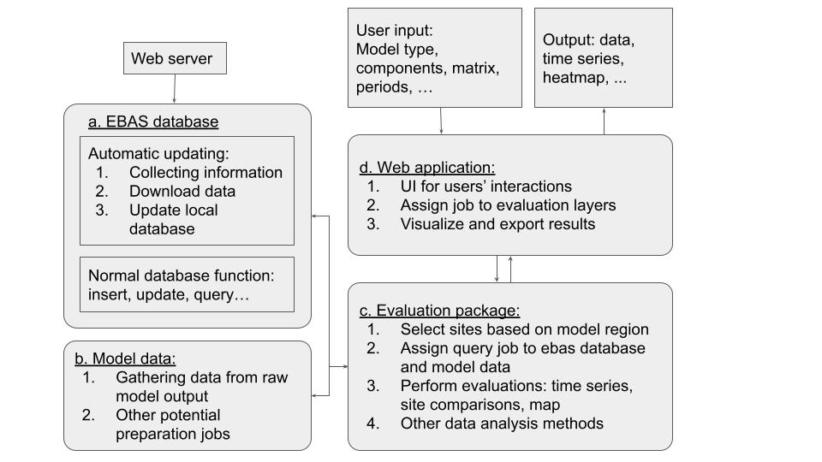

**Figure 1**. Project design flow diagram.

1. **Project Schedule**

The estimations of working hours for this project:

|  |  |  |
| --- | --- | --- |
| Tasks | Hours | Workers |
| EBAS database | 1 week work hour | Chuanlong Zhou |
| Model database | 2 weeks work hour | Zhuyun Ye |
| Model evaluation server | 1 week work hour | Chuanlong Zhou |
| Model evaluation package | 2 weeks work hour | Zhuyun Ye& Chuanlong Zhou |
| Web application | 2 weeks work hour | Chuanlong Zhou |
| Testing& debugging | 1 week work hour | Zhuyun Ye& Chuanlong Zhou |